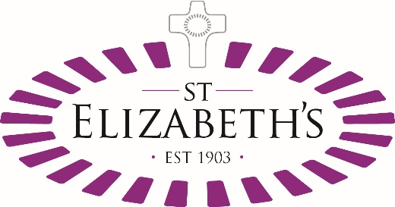

Person Specification

Post: Positive Behaviour Support Lead
Location: St Elizabeth’s Centre

 | Essential | Desirable
Qualifications | Education – Bachelors Degree in relevant field; Psychology, Mental Health, Intellectual Disability, Positive Behaviour Support, Applied Behaviour Analysis (ABA).  Master’s Degree or Post Graduate qualification/specialisation in relevant field.  BCBA Certified. | Additional qualification in Leadership or management.
Experience | Relevant experience of managing teams, working with young people with varying degrees of learning disabilities.  Experience of working in MDTs  Experience of managing budgets and human resource.  Experience of working with young people who have complex diagnosis.  Experience of working successfully with young people who present behaviour that challenges.  Experience of managing staff and providing both management and support supervision.  Experienced at running and leading group sessions.  Influencing and motivating colleagues in working with young people who present behaviour that challenges.  Expert use of positive behaviour support and communication techniques; ABA, function analysis, PEC’s, ABC’s  Experienced in managing children and young people during crisis intervention including the use when necessary of physical intervention techniques. | Experience of working in a variety of special needs settings such as; residential, academic, play schemes and respite.  Experience in training staff teams.  Experience of working with professionals from multi-disciplinary teams and inter agency working.  Experience/training in Behaviour Support Techniques or Physical intervention e.g. MAPA, TEAM TEACH, SCIP, etc.
Knowledge and understanding | Understanding of children and their development.  Good understanding of ASD, language and communication.  Well Developed knowledge of policies and procedures relevant to children with complex needs.  Substantial knowledge of Child Protection / Safeguarding guidance and procedures  Best practice in positive behaviour support, de-escalation, crisis management and physical interventions  Health and Safety | Epilepsy and other neurological conditions.  Anger management strategies.  Building self-esteem and confidence.  Medication administration and knowledge of anti-psychotic, psycho-stimulant, anti-convulsant medication.
Abilities and Skills | Excellent written and verbal communication skills.  Good planning and organisational skills with an ability to prioritise own work.  Ability to plan and work through complex issues.  Effective and accurate record keeping  Assertiveness  Ability to use initiative and work across teams.  IT skills – use of Microsoft Word, Outlook and Excel at a intermediate level. | .
Special circumstances | Commitment to the strategic Direction and operational delivery at St. Elizabeth’s.  Commitment to the ethos and values of St. Elizabeth’s Centre.  Keen to learn and willingness to undertake further training/qualifications relevant to the role and development of the service.  Ability to work occasional weekends and evenings as required.  Suitability to work with Vulnerable Children.
Reasonable adjustments will be considered where applicable under the Equality Act 2010

